Suppl 5. Subgroup analysis based on immune-checkpoint inhibitor type.
(A) Anemia (Grade I–V)
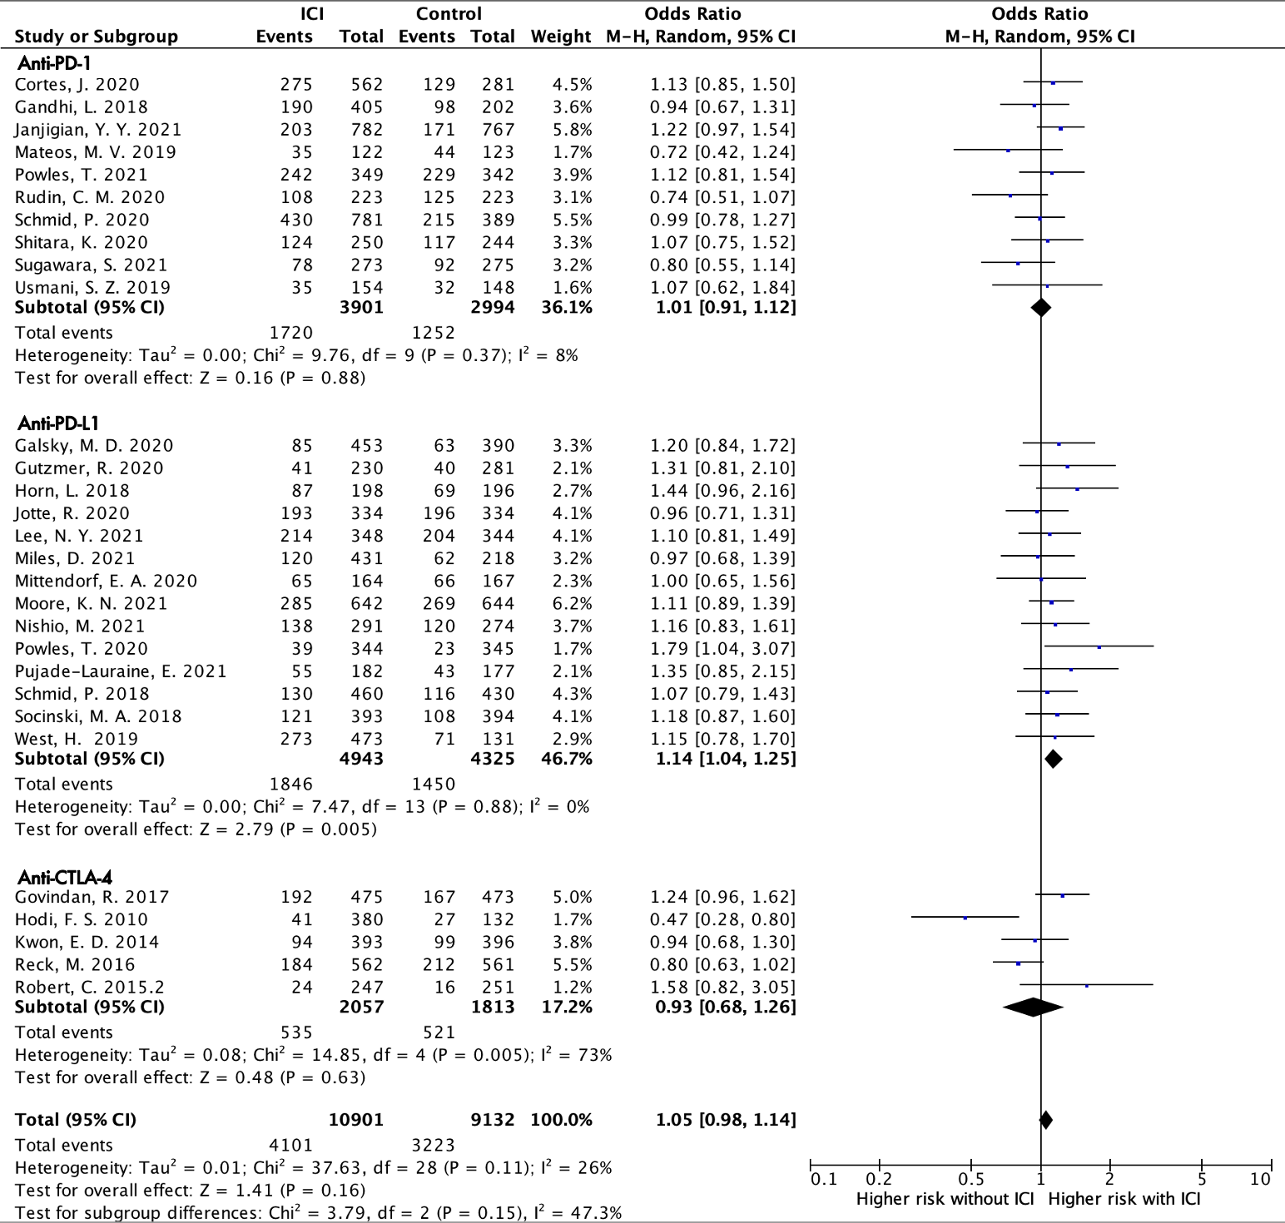
(B) Neutropenia (Grade I–V)
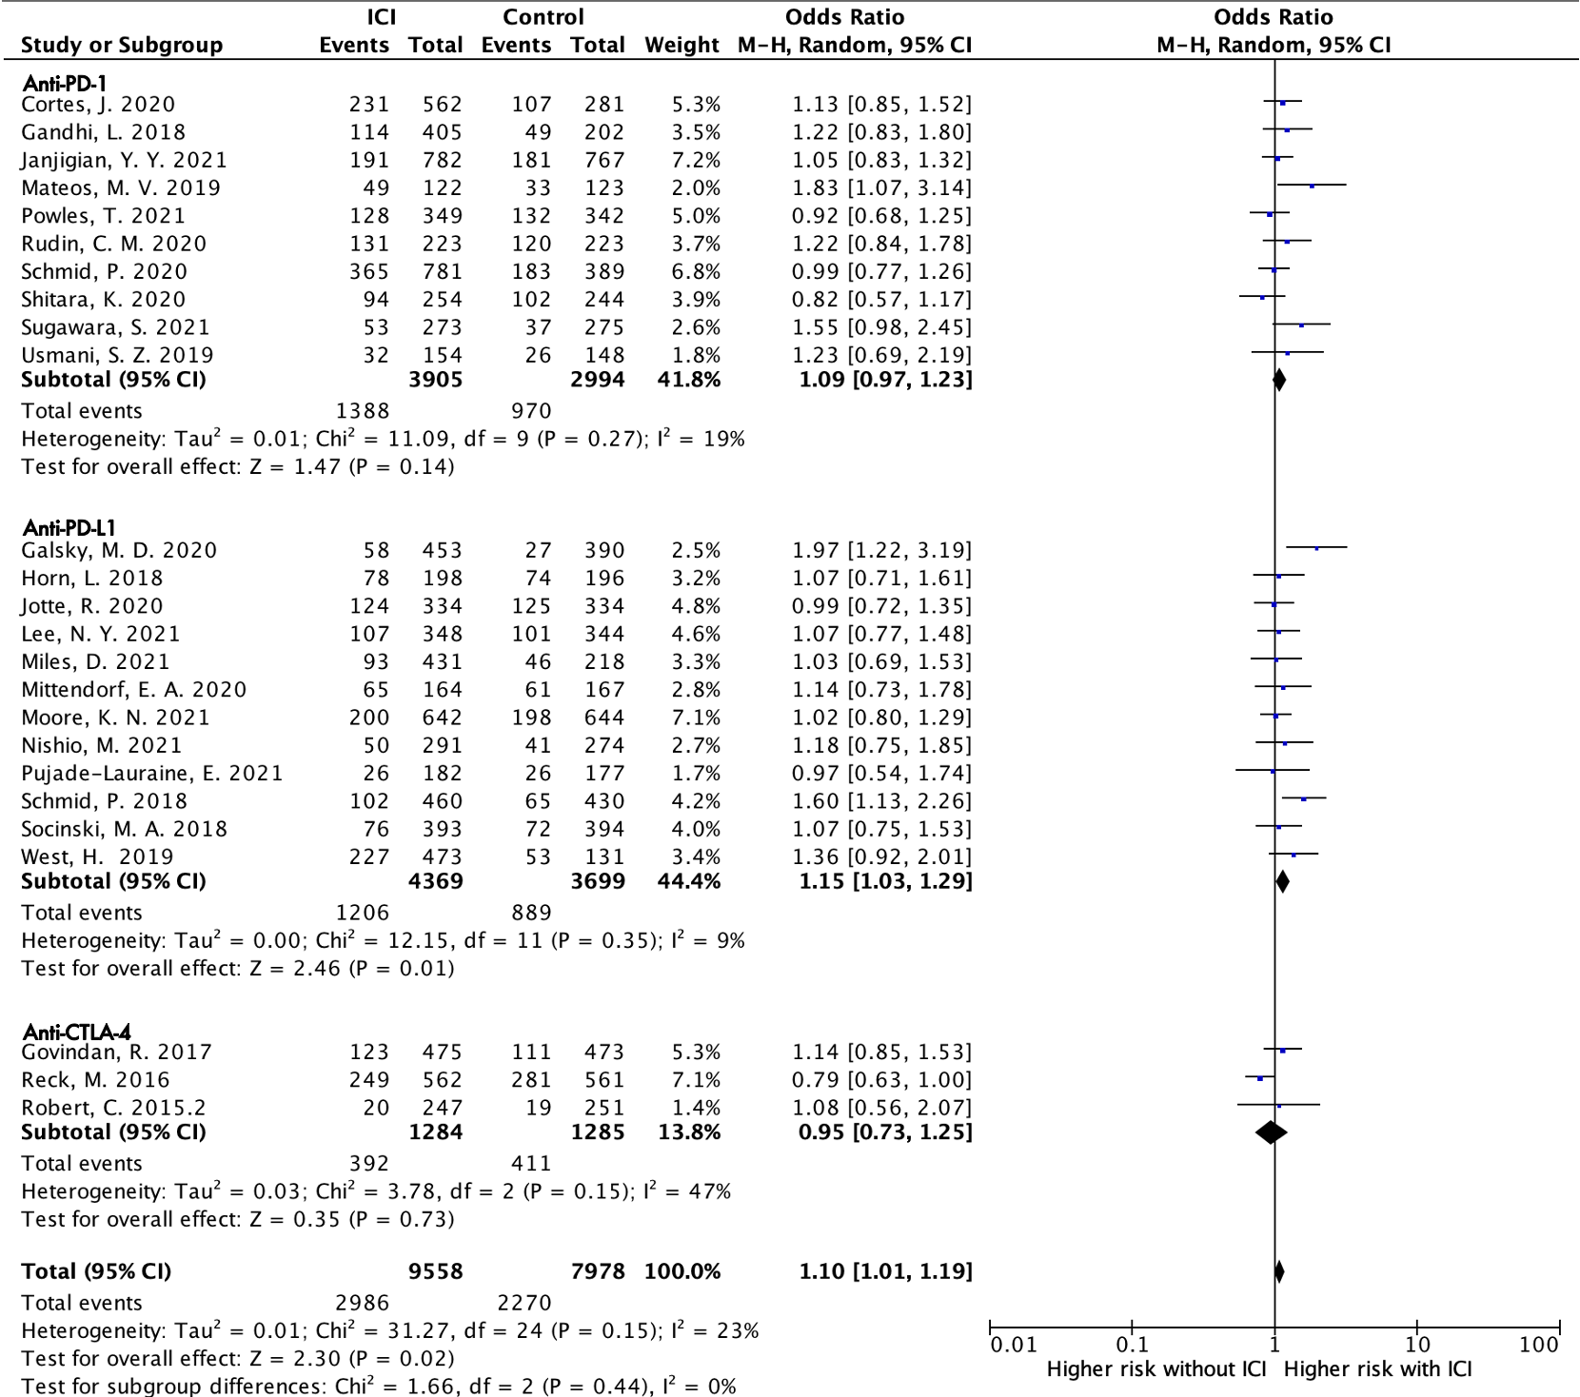

(C) Thrombocytopenia (Grade I–V)
